**CONTENTS**

|  |  |  |
| --- | --- | --- |
| **Sr. No.** | **TITLE** | **Page No.** |
|  | Introduction | 2 |
|  | Requirement analysis (SDLC) | 3-4 |
|  | Software & hardware requirement | 5 |
|  | System analysis | 6 |
|  | Design Phase | 7 |
|  | Development Phase | 8-9 |
|  | Testing | 10-11 |
|  | Coding | 12-88 |
|  | Screen Shots | 89-92 |
|  | Tables | 93-94 |
|  | Conclusion | 95 |
|  | Bibliography | 95 |

**1 INTRODUCTION**

**Brief overview of Student’s Record**

To develop aStudent’sRecord, we take care of Student’s all details Like Student Personl Detail, Student’s Acadamic Detail, Student’s Identity Detail.

* We save Student’s record in the database
* Record view from database.
* Record update in the database and record delete in the database.

**Advantages to both end users & developers**

The system is useful in various ways as the information about the students who are taking the free services from the college all the details are already stored in the database , so the service is done in no time . All the information about the books are also maintained in the database

**Goal and need:**

**Goal:** With every going day the need to be where the inflow of student request exceeds that which can be handled manually. Hence computerization of students receipt request of the all information through the computerization brings better facilitates and better services.

Quicker processing of book receipt would mean better service to the students. It would also help in the complexity of maintaining the records manually and thus less time is wasted on rework. Proper maintenance of the students information timely dispatching of the records.

**Need:** To develop a Students Record as from manual system to computerized system, and to take care of Records of the various departments.

The current manual system is slow laborious and error prone to computerize the same for quicker efficient results.

2

SDLC

**REQUIRMENT ANALYSIS**

The general methodology in developing a system is involved in different phases is as follows

* Requirement Analysis Phase
* Design Phase
* Development Phase
* Coding Phase
* Testing Phase

**Requirement analysis phase:**

This phase includes the identification of the problem, in order to identify the problem; we have to know information about the problem, the purpose of the evaluation for problem to be known. We have to clearly know about the client’s requirements and the objectives of the project.

**Design phase:**

S/W design is a process through which the requirements are translated into a representation of an s/w. One of the software requirements have been analyzed and specified, the s/w design involves three technical activities: design, coding generation and testing.

**Development phase:**

The development phase includes choosing of a suitable s/w to solve the particular problem given. The various facilities and the sophistication in the selected s/w give a better development of the problem***.***

**Coding phase:**

The coding phase is for translating the design of the system produced during the design phase into code in a given programming language, which can

**3. Software & Hardware Requirements**

**Software Requirements:**

Platform - Windows (2000/XP)

Software - JDK 5.0

Front End - JAVA

Back End - Ms-Access.

**Hardware Requirements:**

Processor - Intel Celeron class Processor with 2.0 GHz

RAM - 256 MB

Hard Disk - 40 GB

Keyboard - 101 keys

Mouse - Any pointing device

**4. SYSTEM ANALYSIS**

Analysis is the detailed study of the various operations performed by a system and their relationships within and outside of the system. A key question is: What must be done to solve the problem? One aspect of analysis is defining the boundaries of the system and determining whether or not candidate system should consider other related systems.

* During analysis,
* Data are collected on the
* Data files,
* Decision points, and
* Transactions handled by the present system.

System analysis means firstly, we check what the requirement for is given project in the system.

There are many requirements to run the project in our system.

* Mouse
* Keyboard
* Operating system
* RAM
* Hard Disk
* Database
* Software need according to project

**5. FEASIBILITY ANALYSIS (DESIGN PHASE)**

Feasibility study is an important phase in the software development process. It enables the developer to have an assessment of the product being developed. It refers to the feasibility study of the product in terms of outcomes of the product, operational use and technical support required for implementing it.

Feasibility study should be performed on the basis of various criteria and parameters. The various feasibility studies are:

* Economic Feasibility
* Operational Feasibility
* Technical Feasibility
* **Economic Feasibility:** It refers to the benefits or outcomes we are deriving from the product as compared to the total cost we are spending for developing the product. If the benefits are more or less the same as the older system, then it is not feasible to develop the product.

* **Operational Feasibility:** It refers to the feasibility of the product to be operational. Some products may work very well at design and implementation but may fail in the real time environment. It includes the study of additional human resource required and their technical expertise.
* **Technical Feasibility:** It refers to whether the software that

is available in the market fully supports the present application. It studies the pros and cons of using a particular software for the development and its feasibility. It also studies the additional training needed to be given to the people to make the application work.

**6. DEVELOPMENT PHASE**

When the chronicle of computer languages is written, the following will be said: B led to C, C evolved into C++, and C++ set the stage for Java. To understand the reasons that drove the creation, the forces that shaped it, and the legacy that it inherits. Like the successful compute languages that came before, Java is a blend of the best elements of its rich heritage combined with the innovative concepts required by its unique environment.

**JAVA’S FEATURE:**

Although the fundamental forces that necessitated the invention of Java are portability and security, other factors also played an important role in molding the final form of the language and are given by

* Simple
* Object Oriented
* Portable
* Robust
* Security
* Multithreaded
* Interpreted and High performance
* Distributed
* Dynamic
* Garbage Collection
* No Pointers
* Simplicity

**Simple**

Java was designed to be easy for the professional programmer to learn and use effectively. Java will be even easy if we already through in the concept of object oriented.

**Object Oriented**

The Java programming language is object oriented, which makes program design focus on what you are dealing with rather than on how you are going to do something. This makes it more useful for programming in sophisticated projects because one can break the things down into understandable components. A big benefit is that these components can then be reused.

Object oriented languages use the paradigm of classes. In simple term, a class includes both the data and functions to operate on the data.

**Portable**

A programmer no longer has to write one program to run on a Macintosh, another program to run on a Windows machine, still another to run on UNIX machine, and so on. In other words, with Java, developers write their programs only once. The virtual machine is what gives Java is cross platform capabilities. Rather than being compiled into machine language, which is different for each operating systems and computer architecture, Java code is compiled into byte codes.

**Robust**

The multi platform environment of the web places extraordinary demands on a program, because the program must execute reliably in a variety of systems. Thus, the ability to create robust programs was given a high priority in the design of Java. However, it also checks our code at run time. In fact, many space hard-to-down bugs that often turn up in hard-to reproduce run time situations are simply impossible to create in Java.

**7. LIFE CYCLE MODELS (TESTING PHASE)**

The stage of planning the development process involves defining a define, develop, test, deliver, operate, and maintain a software product. Different lifecycle models emphasize different aspects of the lifecycle and no single lifecycle model is suitable for all software products. A lifecycle model that is understood and accepted by all concerned parties improves project communication and enhances project manageability, resource allocation, cost control, and product quality.

**The Phased Life Cycle Model**

The phased lifecycle model represents software lifecycle as a series of successive activities. Each phase requires well-defined input information, utilizes well-defined processes and results in well-defined products. The phased model consists of following phases.

**Analysis, Design, Implementation, System Testing and Maintenance**

This model is sometimes called the Waterfall Chart, the implication being that the products cascade from one level to another in smooth progression.

|  |  |  |  |  |
| --- | --- | --- | --- | --- |
| Analysis | Design | Implementation | System Testing | Maintenance |
| Planning,  User needs  Definition | Design  Details | Code, debug and Test | Integration & Acceptance | Enhance, Fix Adapt |

The **Analysis Stage** consists of Planning and Requirements definition Major include understanding the customer’s problem, performing A feasibility study, developing a recommended solution strategy, determining the acceptance criteria and planning development process. The products of planning are a System definition and a project plan.

The **Software Design** follows analysis. Design is concerned with its software components, specifying relationships among components specifying some structure, maintaining a record of design decisions and providing blueprint implementation phase. Design consists of detailed design and Architectural design.

The **implementation** phase of software development involves translation design specification into source code, and debugging, documentation and unit testing the source code. To enhance the quality of the software the methods are structured control constructs, built in and user defined data types, secure type checking, flexible scope rules exception handling mechanism, concurrency constructs and separates compilation modules.

**System Testing** involves two kinds of testing integration testing and acceptance testing. Developing a strategy for integrating the components of a software system into a functioning whole requires careful planning so that modules are available for integration when needed. Acceptance testing involves planning and execution of various tests in order to demonstrate that the implemented system satisfies the requirements document.

The **Maintenance** phase comes after the acceptance by the customer and release of the system for production work. Maintenance activities include enhancements of capabilities, adaptation of software to new processing environments, and correction of software bugs.

**This project** follows the Phased Life Cycle Model or the Water Fall model to a large extent.

8

CODING

/*******************************************************************WELCOME FORM***********************/

import java.awt.*;

import java.awt.event.*;

import javax.swing.*;

public class WelcomeForm implements ActionListener

{

JFrame f;

JLabel l1,l2,l3;

JButton b1;

Font f1,f2,f3;

ImageIcon image;

WelcomeForm() //CONSTRUCTOR START

{

//JOptionPane.showMessageDialog(null,"WELCOME FORM");

f = new JFrame("# WELCOME FORM #");

f.setDefaultCloseOperation(JFrame.EXIT_ON_CLOSE); // CLOSE THE WINDOW

f.setSize(1000, 650);// window size

f.setLayout(null);

f.setVisible(true);

Container c=f.getContentPane();

c.setBackground(Color.orange);

ImageIcon image=new ImageIcon("Images/imag.PNG");

l3=new JLabel("");

l3.setBounds(120,200,750,350);

l3.setIcon(image);

f.add(l3);

f1 = new Font("Times New Roman",Font.BOLD|Font.CENTER_BASELINE,25);

f2 = new Font("Century Schoolbook",Font.BOLD,10);

f3 = new Font("Elephant",Font.BOLD,40);

l1 = new JLabel("HELLO WELCOME TO EVERYBODY");

l1.setBounds(250,40,515,30);

l1.setForeground(Color.BLUE);

l1.setFont(f1);

f.add(l1);

l2 = new JLabel("All is Well ||All is Well ");

l2.setBounds(550,80,200,15);

l2.setFont(f2);

l2.setForeground(Color.black);

f.add(l2);

b1 = new JButton("SSMV");

b1.setBounds(420,250,200,40);

b1.setFont(f3);

b1.setBackground(Color.black);

b1.setForeground(Color.green);

b1.addActionListener(this);

f.add(b1);

}//CONSTRUCTOR CLOSE

public void actionPerformed(ActionEvent ae) //ACTIONLISTENER OF METHOD

{

try

{

new LoginForm();

f.setVisible(false);

}

catch(Exception e)

{

System.out.println("EXCEPTION OF actionPerformed() IN WelcomeFormClass = " + e.getMessage());

}

} //ACTIONLISTENER OF METHOD CLOSE

public static void main(String args[])

{

new WelcomeForm();

}

}

/****************************LOGINFORM*************************************/

import java.awt.*;

import java.awt.event.*;

import javax.swing.*;

public class LoginForm implements ActionListener

{

JFrame f;

JLabel label1, label2,l1,l2,l3, redColor, greenColor;

TextField t1, t2;

JButton b1,b2,b3;

Font f1,f2,f3;

ImageIcon image;

LoginForm() //CONSTRUCTOR START

{

//JOptionPane.showMessageDialog(null,"LOGIN FORM");

f = new JFrame("# LOGIN FORM #");

f.setDefaultCloseOperation(JFrame.EXIT_ON_CLOSE); // CLOSE THE WINDOW

f.setSize(1010, 650);// window size

f.setLayout(null);

f.setVisible(true);

ImageIcon image=new ImageIcon("Images/ima.PNG");

l3=new JLabel("");

l3.setBounds(450,50,650,500);

l3.setIcon(image);

f.add(l3);

Container c=f.getContentPane();

c.setBackground(Color.green);

f1 = new Font("Century Schoolbook",Font.BOLD|Font.ITALIC|Font.CENTER_BASELINE,20);

f2 = new Font("Century Schoolbook",Font.BOLD,10);

f3 = new Font("Century Schoolbooki",Font.BOLD,16);

label1 = new JLabel("STUDENT MANAGEMENT RECORD");

label1.setBounds(100,20,515,30);

label1.setFont(f1);

label1.setForeground(Color.red);

f.add(label1);

label2 = new JLabel("Work is|the worship");

label2.setBounds(330,50,200,15);

label2.setFont(f2);

label2.setVerticalAlignment(JLabel.CENTER);

label2.setForeground(Color.BLUE);

f.add(label2);

l1 = new JLabel("USER NAME");

l1.setBounds(120, 190, 150, 30);

l1.setForeground(Color.black);

l1.setFont(f3);

f.add(l1);

l2 = new JLabel("PASSWORD");

l2.setBounds(120, 250, 150, 30);

l2.setForeground(Color.black);

l2.setFont(f3);

f.add(l2);

redColor = new JLabel();// use for validation

redColor.setBounds(100,100,300,30);

redColor.setForeground(Color.RED);

f.add(redColor);

greenColor = new JLabel();// use for validation

greenColor.setBounds(100,100,300,30);

greenColor.setForeground(Color.BLUE);

f.add(greenColor);

b1 = new JButton("LOGIN");

b1.setBounds(120, 400, 90, 35);

b1.addActionListener(this);

b1.setBackground(Color.blue);

b1.setForeground(Color.white);

f.add(b1);

b2 = new JButton("RESET");

b2.setBounds(230, 400, 90, 35);

b2.addActionListener(this);

b2.setBackground(Color.blue);

b2.setForeground(Color.white);

f.add(b2);

b3 = new JButton("BACK");

b3.setBounds(340, 400, 90, 35);

b3.addActionListener(this);

b3.setBackground(Color.blue);

b3.setForeground(Color.white);

f.add(b3);

t1 = new TextField("student");

t1.setBounds(250, 190, 180, 30);

t1.setFont(f3);

t1.setBackground(Color.black);

t1.setForeground(Color.white);

f.add(t1);

t2 = new TextField("");

t2.setBounds(250, 250, 180, 30);

t2.setForeground(Color.black);

t2.setEchoChar('*');// password symbol

t2.setFont(f3);

f.add(t2);

}// END CONSTRUCTOR

public void actionPerformed(ActionEvent ae)

{

try

{

String loginButton = "LOGIN";

String resetButton = "RESET";

String backButton = "BACK";

String s = ae.getActionCommand();

if(loginButton.equals(s))

{

if(t1.getText().equals(""))

{

redColor.setText("PLEASE ENTER USERNAME!");

greenColor.setText("");

}

else if(!(t1.getText().equals("student")))

{

redColor.setText("INVALID USERNAME !");

greenColor.setText("");

}

else if(t2.getText().equals(""))

{

redColor.setText("PLEASE ENTER PASSWORD!");

greenColor.setText("");

}

else if(!(t2.getText().equals("student")))

{

redColor.setText("INVALID PASSWORD !");

greenColor.setText("");

}

else if(t2.getText().equals("student")||t2.getText().equals("student"))

{

greenColor.setText("LOGINFORM SUCCESSFULLY");

redColor.setText("");

new MainForm();

f.setVisible(false);

}

else

{

redColor.setText("INVALID USERNAME OR PASSWORD !!");

greenColor.setText("");

}

}// end of main if

if(resetButton.equals(s))

{

t1.setText("");

t2.setText("");

redColor.setText("");

greenColor.setText("");

}

if(backButton.equals(s))

{

new WelcomeForm();

f.setVisible(false);

}

}// end of try block

catch(Exception e)

{

System.out.println("EXCEPTION OF actionPerformed() IN LoginFormClass = " + e.getMessage());

}

} // END OF ACTION METHOD

public static void main(String args[])

{

new LoginForm();

}

}

/***************************************************************MAINFORM

*****************************************************************/

import java.awt.*;

import java.awt.event.*;

import javax.swing.*;

import java.sql.*;

public class MainForm implements ActionListener

{

JFrame f;

JLabel label1,label2,l1,l2,l3,l4,la,lb,l5,label3,l6,l7,l8,label4,lc,ld,l9,le,lf,l10,l11,l12,

l13,l14,l15,l16,lg,l17,l18,l19,l20,l21,l22,l23,l24,l25,l26,l27,

l28,l29,l30,l31,l32,l33,l34,l35,l36,label5,l37,l38,l39,l40;

JTextField t1,t2,t3,t4,t5,t6,t7,t8,t9,t10,t11,t12,t13,t14,t15,t16,t17,t18,t19,t20,

t21,t22,t23,t24,t25,t26,t27,t28,t29,t30,t31,t32,t33,t34,t35,t36,t37,t38,t39,t40;

Choice c1,c2,c3,c4,c5,c6,c7;

JButton b1,b2,b3,b4,b5,b6,b7;

Font ff,fff;

Connection con;

PreparedStatement pstmt;

ImageIcon saveImage,updateImage,resetImage,deleteImage,homeImage,backImage,searchImage;

MainForm()

{

JOptionPane.showMessageDialog(null,"MainForm");

f=new JFrame("# MAIN FORM #");

f.setSize(1360,720);// window size

f.setLayout(null);

f.setVisible(true);

f.setDefaultCloseOperation(JFrame.EXIT_ON_CLOSE); // CALL WHEN CLOSE THE WINDOW

saveImage = new ImageIcon("Images/saveImage.png");

updateImage = new ImageIcon("Images/updateImage.png");

resetImage = new ImageIcon("Images/resetImage.png");

deleteImage = new ImageIcon("Images/deleteImage.png");

homeImage = new ImageIcon("Images/homeImage.png");

backImage = new ImageIcon("Images/backImage.png");

searchImage = new ImageIcon("Images/searchImage.png");

ff = new Font("Century Schoolbook",Font.BOLD,22);

fff = new Font("Century Schoolbook",Font.BOLD,15);

label1=new JLabel("@@@@@ STUDENT RECORD @@@@@");

label1.setBounds(300,20,500,20);

label1.setForeground(Color.RED);

label1.setFont(ff);

f.add(label1);

label2=new JLabel("STUDENT PERSONAL DETAIL");

label2.setBounds(20,55,250,20);

label2.setForeground(Color.BLUE);

label2.setFont(fff);

f.add(label2);

l1=new JLabel("Student Name*");

l1.setBounds(20,80,100,20);

f.add(l1);

l2=new JLabel("Father's Name*");

l2.setBounds(20,110,100,20);

f.add(l2);

l3=new JLabel("Mother's Name*");

l3.setBounds(20,140,100,20);

f.add(l3);

l4=new JLabel("Date of Birth*");

l4.setBounds(20,170,100,20);

f.add(l4);

la=new JLabel("Gender*");

la.setBounds(20,200,100,20);

f.add(la);

lb=new JLabel("Category*");

lb.setBounds(20,230,100,20);

f.add(lb);

l5=new JLabel("Address*");

l5.setBounds(20,270,100,20);

f.add(l5);

label3=new JLabel("STUDENT IDENTITY DETAIL");

label3.setBounds(20,435,250,20);

label3.setForeground(Color.BLUE);

label3.setFont(fff);

f.add(label3);

l6=new JLabel("Mobile Number*");

l6.setBounds(20,460,100,20);

f.add(l6);

l7=new JLabel("Aadhar Number*");

l7.setBounds(20,490,100,20);

f.add(l7);

l8=new JLabel("Email ID*");

l8.setBounds(20,520,100,20);

f.add(l8);

label4=new JLabel("STUDENT ACADAMIC DETAIL");

label4.setBounds(400,55,250,20);

label4.setForeground(Color.BLUE);

label4.setFont(fff);

f.add(label4);

lc=new JLabel("10th Board*");

lc.setBounds(300,80,70,20);

f.add(lc);

ld=new JLabel("10th Stream*");

ld.setBounds(500,80,80,20);

f.add(ld);

l9=new JLabel("College Name*");

l9.setBounds(710,80,120,20);

f.add(l9);

l10=new JLabel("10th MM*");

l10.setBounds(300,110,70,20);

f.add(l10);

l11=new JLabel("Obt.Marks*");

l11.setBounds(500,110,80,20);

f.add(l11);

l12=new JLabel("Marks in %*");

l12.setBounds(710,110,80,20);

f.add(l12);

le=new JLabel("12th Board*");

le.setBounds(300,140,70,20);

f.add(le);

lf=new JLabel("12th Stream*");

lf.setBounds(500,140,80,20);

f.add(lf);

l13=new JLabel("College Name*");

l13.setBounds(710,140,120,20);

f.add(l13);

l14=new JLabel("12th MM*");

l14.setBounds(300,170,70,20);

f.add(l14);

l15=new JLabel("Obt.Marks*");

l15.setBounds(500,170,80,20);

f.add(l15);

l16=new JLabel("Mark in %*");

l16.setBounds(710,170,80,20);

f.add(l16);

lg=new JLabel("B.C.A*");

lg.setBounds(300,200,70,20);

f.add(lg);

l17=new JLabel("B.C.A.MM*");

l17.setBounds(500,200,80,20);

f.add(l17);

l18=new JLabel("B.C.A.MNMM*");

l18.setBounds(710,200,80,20);

f.add(l18);

l19=new JLabel("I Sem.MM*");

l19.setBounds(300,230,80,20);

f.add(l19);

l20=new JLabel("I Sem.Obt.M*");

l20.setBounds(500,230,80,20);

f.add(l20);

l21=new JLabel("Marks in %*");

l21.setBounds(710,230,80,20);

f.add(l21);

l22=new JLabel("II Sem.MM*");

l22.setBounds(300,260,80,20);

f.add(l22);

l23=new JLabel("II Sem.Obt.M*");

l23.setBounds(500,260,80,20);

f.add(l23);

l24=new JLabel("Marks in %*");

l24.setBounds(710,260,80,20);

f.add(l24);

l25=new JLabel("III Sem.MM*");

l25.setBounds(300,290,80,20);

f.add(l25);

l26=new JLabel("III Sem.Obt.M*");

l26.setBounds(500,290,80,20);

f.add(l26);

l27=new JLabel("Marks in %*");

l27.setBounds(710,290,80,20);

f.add(l27);

l28=new JLabel("IV Sem.MM*");

l28.setBounds(300,320,80,20);

f.add(l28);

l29=new JLabel("IV Sem.Obt.M");

l29.setBounds(500,320,80,20);

f.add(l29);

l30=new JLabel("Marks in %*");

l30.setBounds(710,320,80,20);

f.add(l30);

l31=new JLabel("V Sem.MM*");

l31.setBounds(300,350,80,20);

f.add(l31);

l32=new JLabel("V Sem.Obt.M*");

l32.setBounds(500,350,80,20);

f.add(l32);

l33=new JLabel("Marks in %*");

l33.setBounds(710,350,80,20);

f.add(l33);

l34=new JLabel("VI Sem.MM*");

l34.setBounds(300,380,80,20);

f.add(l34);

l35=new JLabel("VI Sem.Obt.M");

l35.setBounds(500,380,80,20);

f.add(l35);

l36=new JLabel("Marks in %*");

l36.setBounds(710,380,80,20);

f.add(l36);

label5=new JLabel("UNIVERSITY IDENTITY DETAIL");

label5.setBounds(300,435,265,20);

label5.setForeground(Color.BLUE);

label5.setFont(fff);

f.add(label5);

l37=new JLabel("Registration No*");

l37.setBounds(300,460,100,20);

f.add(l37);

l38=new JLabel("Roll Number*");

l38.setBounds(300,490,100,20);

f.add(l38);

l39=new JLabel("Enrollment No*");

l39.setBounds(300,520,100,20);

f.add(l39);

l40=new JLabel("Search by Roll No*");

l40.setBounds(900,230,180,20);

l40.setForeground(Color.BLUE);

l40.setFont(fff);

f.add(l40);

b1=new JButton("SAVE",saveImage);

b1.setBounds(900,450,125,40);

b1.addActionListener(this);

f.add(b1);

b2=new JButton("UPDATE",updateImage);

b2.setBounds(900,530,125,40);

b2.addActionListener(this);

f.add(b2);

b3=new JButton("RESET",resetImage);

b3.setBounds(1050,450,125,40);

b3.addActionListener(this);

f.add(b3);

b4=new JButton("DELETE",deleteImage);

b4.setBounds(1050,530,125,40);

b4.addActionListener(this);

f.add(b4);

b5=new JButton("HOME",homeImage);

b5.setBounds(1200,450,125,40);

b5.addActionListener(this);

f.add(b5);

b6=new JButton("LOGOUT",backImage);

b6.setBounds(1200,530,125,40);

b6.addActionListener(this);

f.add(b6);

b7=new JButton("SEARCH",searchImage);

b7.setBounds(1050,320,130,40);

b7.addActionListener(this);

f.add(b7);

c1=new Choice();

c1.add("Select Gender");

c1.add("Male");

c1.add("Female");

c1.setBounds(120,200,120,20);

f.add(c1);

c2=new Choice();

c2.add("Select Category");

c2.add("General");

c2.add("OBC");

c2.add("SC");

c2.add("ST");

c2.setBounds(120,230,120,20);

f.add(c2);

c3=new Choice();

c3.add("Select Board");

c3.add("UP Board");

c3.add("CBSC Board");

c3.setBounds(370,80,120,20);

f.add(c3);

c4=new Choice();

c4.add("Select Stream");

c4.add("Science");

c4.add("Commerce");

c4.add("Art");

c4.setBounds(580,80,120,20);

f.add(c4);

c5=new Choice();

c5.add("Select Board");

c5.add("UP Board");

c5.add("CBSC Board");

c5.setBounds(370,140,120,20);

f.add(c5);

c6=new Choice();

c6.add("Select Stream");

c6.add("Science");

c6.add("Computer Science");

c6.add("Commerce");

c6.setBounds(580,140,120,20);

f.add(c6);

c7=new Choice();

c7.add("B.C.A");

c7.add("I year");

c7.add("II year");

c7.add("III year");

c7.setBounds(370,200,120,20);

f.add(c7);

/****** TextField OF PERSONAL DETAIL******/

t1=new JTextField("");

t1.setBounds(120,80,120,20);

f.add(t1);

t2=new JTextField("");

t2.setBounds(120,110,120,20);

f.add(t2);

t3=new JTextField("");

t3.setBounds(120,140,120,20);

f.add(t3);

t4=new JTextField("");

t4.setBounds(120,170,120,20);

f.add(t4);

t5=new JTextField("");

t5.setBounds(120,260,150,40);

f.add(t5);

/****** TextField OF IDENTITY DETAIL******/

t6=new JTextField("");

t6.setBounds(120,460,120,20);

f.add(t6);

t7=new JTextField("");

t7.setBounds(120,490,120,20);

f.add(t7);

t8=new JTextField("");

t8.setBounds(120,520,120,20);

f.add(t8);

/****** TextField OF ACADAMIC DETAIL******/

t9=new JTextField("");

t9.setBounds(800,80,120,20);

f.add(t9);

t10=new JTextField("");

t10.setBounds(370,110,50,20);

f.add(t10);

t11=new JTextField("");

t11.setBounds(580,110,50,20);

f.add(t11);

t12=new JTextField("");

t12.setBounds(800,110,50,20);

f.add(t12);

t13=new JTextField("");

t13.setBounds(800,140,120,20);

f.add(t13);

t14=new JTextField("");

t14.setBounds(370,170,50,20);

f.add(t14);

t15=new JTextField("");

t15.setBounds(580,170,50,20);

f.add(t15);

t16=new JTextField("");

t16.setBounds(800,170,50,20);

f.add(t16);

t17=new JTextField("");

t17.setBounds(580,200,50,20);

f.add(t17);

t18=new JTextField("");

t18.setBounds(800,200,50,20);

f.add(t18);

t19=new JTextField("");

t19.setBounds(370,230,50,20);

f.add(t19);

t20=new JTextField("");

t20.setBounds(580,230,50,20);

f.add(t20);

t21=new JTextField("");

t21.setBounds(800,230,50,20);

f.add(t21);

t22=new JTextField("");

t22.setBounds(370,260,50,20);

f.add(t22);

t23=new JTextField("");

t23.setBounds(580,260,50,20);

f.add(t23);

t24=new JTextField("");

t24.setBounds(800,260,50,20);

f.add(t24);

t25=new JTextField("");

t25.setBounds(370,290,50,20);

f.add(t25);

t26=new JTextField("");

t26.setBounds(580,290,50,20);

f.add(t26);

t27=new JTextField("");

t27.setBounds(800,290,50,20);

f.add(t27);

t28=new JTextField("");

t28.setBounds(370,320,50,20);

f.add(t28);

t29=new JTextField("");

t29.setBounds(580,320,50,20);

f.add(t29);

t30=new JTextField("");

t30.setBounds(800,320,50,20);

f.add(t30);

t31=new JTextField("");

t31.setBounds(370,350,50,20);

f.add(t31);

t32=new JTextField("");

t32.setBounds(580,350,50,20);

f.add(t32);

t33=new JTextField("");

t33.setBounds(800,350,50,20);

f.add(t33);

t34=new JTextField("");

t34.setBounds(370,380,50,20);

f.add(t34);

t35=new JTextField("");

t35.setBounds(580,380,50,20);

f.add(t35);

t36=new JTextField("");

t36.setBounds(800,380,50,20);

f.add(t36);

/****** TextField OF UNIVERSITY IDENTITY DETAIL******/

t37=new JTextField("");

t37.setBounds(400,460,120,20);

f.add(t37);

t38=new JTextField("");

t38.setBounds(400,490,120,20);

f.add(t38);

t39=new JTextField("");

t39.setBounds(400,520,120,20);

f.add(t39);

t40=new JTextField("");

t40.setBounds(1060,230,265,30);

f.add(t40);

/************************************* CODE FOR MS ACCESS DATA BASE CONNECTIVITY ***********************************/

try

{

Class.forName("sun.jdbc.odbc.JdbcOdbcDriver");

Connection con = DriverManager.getConnection("jdbc:odbc:yoyo");//source name

System.out.println("connection created");

}

catch(Exception e)

{

System.out.println("connection is not created");

System.out.println("exception is = "+e.getMessage());

}

}//AND OF THE CONSTRUCTOR

public void actionPerformed(ActionEvent ae)

{

String s = ae.getActionCommand();

if(s.equals("SAVE"))

{

if(t1.getText().equals(""))

{

JOptionPane.showMessageDialog(null,"Plz enter Name");

}

else if(t2.getText().equals(""))

{

JOptionPane.showMessageDialog(null,"Plz enter FatherName");

}

else if(t3.getText().equals(""))

{

JOptionPane.showMessageDialog(null,"Plz enter MotherName");

}

else if(t4.getText().equals(""))

{

JOptionPane.showMessageDialog(null,"Plz enter Date of Birth");

}

else if(c1.getSelectedItem().equals("Select Gender"))

{

JOptionPane.showMessageDialog(null,"Plz Selected Gender");

}

else if(c2.getSelectedItem().equals("Select Category"))

{

JOptionPane.showMessageDialog(null,"Plz Selected Category");

}

else if(t6.getText().equals(""))

{

JOptionPane.showMessageDialog(null,"Plz enter Mobile Number");

}

else if(t38.getText().equals(""))

{

JOptionPane.showMessageDialog(null,"Plz enter Roll Number ");

}

else if(t40.getText().equals("180981106008"))

{

JOptionPane.showMessageDialog(null,"data allready has been saved ");

}

else if(t40.getText().equals("180981106022"))

{

JOptionPane.showMessageDialog(null,"data allready has been saved ");

}

else if(t40.getText().equals("180981106031"))

{

JOptionPane.showMessageDialog(null,"data allready has been saved ");

}

else

{

saveAll();

}

}

if(s.equals("UPDATE"))

{

updateAll();

}

if(s.equals("RESET"))

{

if(t40.getText().equals(""))

{

JOptionPane.showMessageDialog(null,"Data Could Not Reset");

}

else

{

resetAll();

}

}

if(s.equals("DELETE"))

{

deleteAll();

}

if(s.equals("HOME"))

{

JOptionPane.showMessageDialog(null, "home page");

homePage();

}

if(s.equals("LOGOUT"))

{

JOptionPane.showMessageDialog(null, "login page");

loginPage();

}

if(s.equals("SEARCH"))

{

if(t40.getText().equals(""))

{

JOptionPane.showMessageDialog(null,"Plz enter Search Name");

}

else

{

searchAll();

}

}

}// END OF actionPerformed() METHOD

void saveAll()

{

try

{

String str = "insert into Dush values (?,?,?,?,?,?,?,?,?,?,?,?,?,?,?,?,?,?,?,?,?,?,?,?,?,?,?,?,?,?,?,?,?,?,?,?,?,?,?,?,?,?,?,?,?,?,?)";

pstmt = con.prepareStatement(str);

String student="1";

pstmt.setString(1,t1.getText());

pstmt.setString(2,t2.getText());

pstmt.setString(3,t3.getText());

pstmt.setString(4,t4.getText());

pstmt.setString(5,c1.getSelectedItem());

pstmt.setString(6,c2.getSelectedItem());

pstmt.setString(7,t5.getText());

pstmt.setString(8,t6.getText());

pstmt.setString(9,t7.getText());

pstmt.setString(10,t8.getText());

pstmt.setString(11,c3.getSelectedItem());

pstmt.setString(12,c4.getSelectedItem());

pstmt.setString(13,t9.getText());

pstmt.setString(14,t10.getText());

pstmt.setString(15,t11.getText());

pstmt.setString(16,t12.getText());

pstmt.setString(17,c5.getSelectedItem());

pstmt.setString(18,c6.getSelectedItem());

pstmt.setString(19,t13.getText());

pstmt.setString(20,t14.getText());

pstmt.setString(21,t15.getText());

pstmt.setString(22,t16.getText());

pstmt.setString(23,c7.getSelectedItem());

pstmt.setString(24,t17.getText());

pstmt.setString(25,t18.getText());

pstmt.setString(26,t19.getText());

pstmt.setString(27,t20.getText());

pstmt.setString(28,t21.getText());

pstmt.setString(29,t22.getText());

pstmt.setString(30,t23.getText());

pstmt.setString(31,t24.getText());

pstmt.setString(32,t25.getText());

pstmt.setString(33,t26.getText());

pstmt.setString(34,t27.getText());

pstmt.setString(35,t28.getText());

pstmt.setString(36,t29.getText());

pstmt.setString(37,t30.getText());

pstmt.setString(38,t31.getText());

pstmt.setString(39,t32.getText());

pstmt.setString(40,t33.getText());

pstmt.setString(41,t34.getText());

pstmt.setString(42,t35.getText());

pstmt.setString(43,t36.getText());

pstmt.setString(44,t37.getText());

pstmt.setString(45,t38.getText());

pstmt.setString(46,t39.getText());

pstmt.setString(47,student);

int result = pstmt.executeUpdate();

if(result==1)

{

JOptionPane.showMessageDialog(null, "DATA HAS BEEN SUCCESSFUULY SAVED");

System.out.println("Data Successfully Saved");

if(result==1)

{

t1.setText("");

t2.setText("");

t3.setText("");

t4.setText("");

c1.select("Select Gender");

c2.select("Select Category");

t5.setText("");

t6.setText("");

t7.setText("");

t8.setText("");

c3.select("Select Board");

c4.select("Select Stream");

t9.setText("");

t10.setText("");

t11.setText("");

t12.setText("");

c5.select("Select Board");

c6.select("Select Stream");

t13.setText("");

t14.setText("");

t15.setText("");

t16.setText("");

c7.select("B.C.A");

t17.setText("");

t18.setText("");

t19.setText("");

t20.setText("");

t21.setText("");

t22.setText("");

t23.setText("");

t24.setText("");

t25.setText("");

t26.setText("");

t27.setText("");

t28.setText("");

t29.setText("");

t30.setText("");

t31.setText("");

t32.setText("");

t33.setText("");

t34.setText("");

t35.setText("");

t36.setText("");

t37.setText("");

t38.setText("");

t39.setText("");

}

}

}

catch(Exception e)

{

System.out.println("EXCEPTION OF actionPerformed() IN LoginFormClass = " + e.getMessage());

}

}// AND OF THE saveAll() METHOD

void updateAll()

{

try

{

String search = t40.getText();

//JOptionPane.showMessageDialog(null,search);

String Name = t1.getText();

String FatherName = t2.getText();

String MotherName = t3.getText();

String DOB = t4.getText();

String Gender = c1.getSelectedItem();

String Category = c2.getSelectedItem();

String Address = t5.getText();

String MobileNumber = t6.getText();

String AadharNumber = t7.getText();

String EmailID = t8.getText();

String CollegeName = t9.getText();

String RegistrationNumber = t37.getText();

String RollNumber = t38.getText();

String EnrollmentNumber = t39.getText();

String query = "update Dush set Name='"+Name+"',FatherName='"+FatherName+"', MotherName='"+MotherName+"',DOB='"+DOB +"',Gender='"+Gender+"',Category='"+Category+"',Address='"+Address+"', MobileNumber ='"+MobileNumber +"',AadharNumber ='"+ AadharNumber +"', EmailID ='"+EmailID +"',CollegeName ='"+CollegeName +"',RegistrationNumber ='"+RegistrationNumber +"',RollNumber ='"+RollNumber+"',EnrollmentNumber='"+EnrollmentNumber +"'where RollNumber='"+search+"'";

pstmt = con.prepareStatement(query);

int result = pstmt.executeUpdate();

//JOptionPane.showMessageDialog(null,result);

if(result==1)

{

JOptionPane.showMessageDialog(null, "DATA SUCCESSFUULY UPDATED");

}

else

{

JOptionPane.showMessageDialog(null, "Data Could Not Update!!!");

}

}

catch(Exception e)

{

System.out.println("Exceptoin in updateAll() method = " +e.getMessage());

System.out.println("Exceptoin in updateAll() method = " +e);

}

}// AND OF THE updateAll() METHOD

void resetAll()

{

try

{

t1.setText("");

t2.setText("");

t3.setText("");

t4.setText("");

c1.select("Select Gender");

c2.select("Select Category");

t5.setText("");

t6.setText("");

t7.setText("");

t8.setText("");

c3.select("Select Board");

c4.select("Select Stream");

t9.setText("");

t10.setText("");

t11.setText("");

t12.setText("");

c5.select("Select Board");

c6.select("Select Stream");

t13.setText("");

t14.setText("");

t15.setText("");

t16.setText("");

c7.select("B.C.A");

t17.setText("");

t18.setText("");

t19.setText("");

t20.setText("");

t21.setText("");

t22.setText("");

t23.setText("");

t24.setText("");

t25.setText("");

t26.setText("");

t27.setText("");

t28.setText("");

t29.setText("");

t30.setText("");

t31.setText("");

t32.setText("");

t33.setText("");

t34.setText("");

t35.setText("");

t36.setText("");

t37.setText("");

t38.setText("");

t39.setText("");

t40.setText("");

}

catch(Exception e) {

System.out.println("Exceptoin in resetAll() method = " +e.getMessage());

System.out.println("Exceptoin in resetAll() method = " +e);

}

}// AND OF THE resetAll() METHOD

void deleteAll()

{

try

{

String search = t40.getText();

//JOptionPane.showMessageDialog(null,search);

String query = "update Dush set student='0' where RollNumber='"+search+"'";

//String query = "delete from Dush where Name='"+search+"'";

pstmt = con.prepareStatement(query);

int result = pstmt.executeUpdate();

//JOptionPane.showMessageDialog(null,result);

if(result==1)

{

JOptionPane.showMessageDialog(null,"Data Successfully Deleted");

t1.setText("");

t2.setText("");

t3.setText("");

t4.setText("");

c1.select("Select Gender");

c2.select("Select Category");

t5.setText("");

t6.setText("");

t7.setText("");

t8.setText("");

c3.select("Select Board");

c4.select("Select Stream");

t9.setText("");

t10.setText("");

t11.setText("");

t12.setText("");

c5.select("Select Board");

c6.select("Select Stream");

t13.setText("");

t14.setText("");

t15.setText("");

t16.setText("");

c7.select("B.C.A");

t17.setText("");

t18.setText("");

t19.setText("");

t20.setText("");

t21.setText("");

t22.setText("");

t23.setText("");

t24.setText("");

t25.setText("");

t26.setText("");

t27.setText("");

t28.setText("");

t29.setText("");

t30.setText("");

t31.setText("");

t32.setText("");

t33.setText("");

t34.setText("");

t35.setText("");

t36.setText("");

t37.setText("");

t38.setText("");

t39.setText("");

t40.setText("");

}

else

{

JOptionPane.showMessageDialog(null, "Data Could Not Delete!!!");

}

}

catch(Exception e)

{

System.out.println("Exceptoin in deleteAll() method = " +e.getMessage());

System.out.println("Exceptoin in deleteAll() method = " +e);

}

}// AND OF THE deleteAll() METHOD

void homePage()

{

try

{

new WelcomeForm();

f.setVisible(false);

}

catch(Exception e) {

System.out.println("Exceptoin in homePage() method = " +e.getMessage());

System.out.println("Exceptoin in homePage() method = " +e);

}

}// AND OF THE homePage() METHOD

void loginPage()

{

try

{

new LoginForm();

f.setVisible(false);

}

catch(Exception e) {

System.out.println("Exceptoin in homePage() method = " +e.getMessage());

System.out.println("Exceptoin in homePage() method = " +e);

}

}// AND OF THE loginPage() METHOD

void searchAll()

{

try

{

String search = t40.getText();

JOptionPane.showMessageDialog(null,search);

Statement st = con.createStatement();

String query = "select * from Dush where RollNumber='"+search+"'and student='1'";

ResultSet rs = st.executeQuery(query);

boolean recordfound = rs.next();

JOptionPane.showMessageDialog(null,recordfound);

if(recordfound)

{

t1.setText(rs.getString("Name"));

t2.setText(rs.getString("FatherName"));

t3.setText(rs.getString("MotherName"));

t4.setText(rs.getString("DOB"));

c1.select(rs.getString("Gender"));

c2.select(rs.getString("Category"));

t5.setText(rs.getString("Address"));

t6.setText(rs.getString("MobileNumber"));

t7.setText(rs.getString("AadharNumber"));

t8.setText(rs.getString("EmailID"));

c3.select(rs.getString("10thBoard"));

c4.select(rs.getString("10thStream"));

t9.setText(rs.getString("CollegeName"));

t10.setText(rs.getString("10thMM"));

t11.setText(rs.getString("10thObtMM"));

t12.setText(rs.getString("10thMarks%"));

c5.select(rs.getString("12thBoard"));

c6.select(rs.getString("12thStream"));

t13.setText(rs.getString("12thCollegeName"));

t14.setText(rs.getString("12thMM"));

t15.setText(rs.getString("12thObtMM"));

t16.setText(rs.getString("12thMarks%"));

c7.select(rs.getString("BCA"));

t17.setText(rs.getString("BCAMM"));

t18.setText(rs.getString("BCANMMM"));

t19.setText(rs.getString("1semMM"));

t20.setText(rs.getString("1semObtMarks"));

t21.setText(rs.getString("1sem%"));

t22.setText(rs.getString("2semMM"));

t23.setText(rs.getString("2semObtMarks"));

t24.setText(rs.getString("2sem%"));

t25.setText(rs.getString("3semMM"));

t26.setText(rs.getString("3semObtMarks"));

t27.setText(rs.getString("3sem%"));

t28.setText(rs.getString("4semMM"));

t29.setText(rs.getString("4semObtMarks"));

t30.setText(rs.getString("4sem%"));

t31.setText(rs.getString("5semMM"));

t32.setText(rs.getString("5semObtMarks"));

t33.setText(rs.getString("5sem%"));

t34.setText(rs.getString("6semMM"));

t35.setText(rs.getString("6semObtMarks"));

t36.setText(rs.getString("6sem%"));

t37.setText(rs.getString("RegistrationNumber"));

t38.setText(rs.getString("RollNumber"));

t39.setText(rs.getString("EnrollmentNumber"));

}

}

catch(Exception e) {

System.out.println("Exceptoin in searchAll() method = " +e.getMessage());

System.out.println("Exceptoin in resetAll() method = " +e);

}

}// AND OF THE searchAll() METHOD

public static void main(String args[])

{

new MainForm();

} // END OF MAIN CLASS

9

SCREEN SHOTS

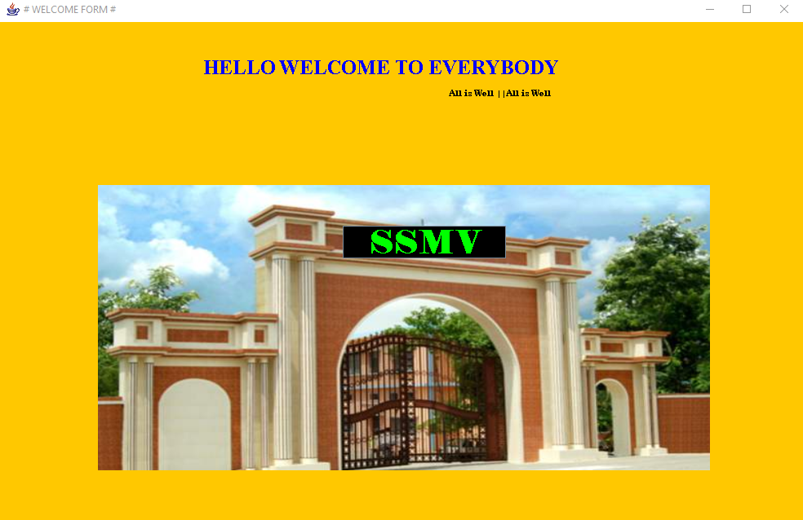

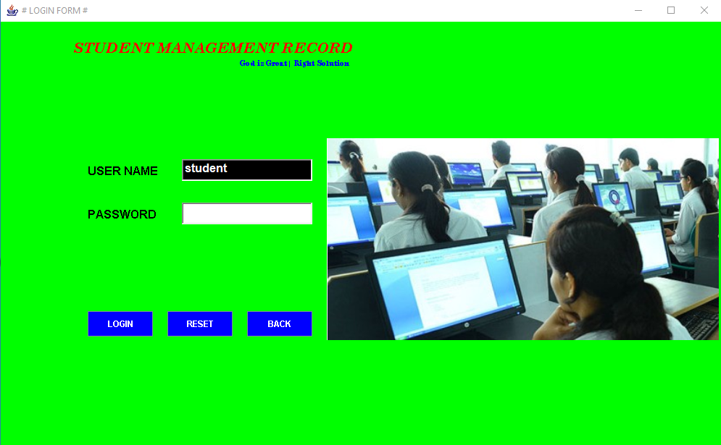

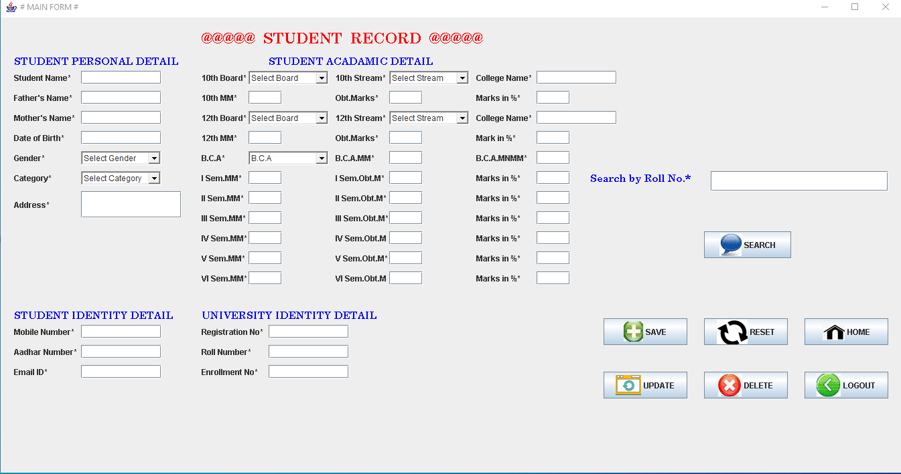

10

TABLES

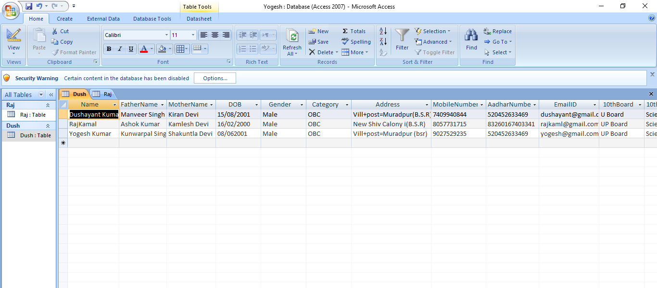

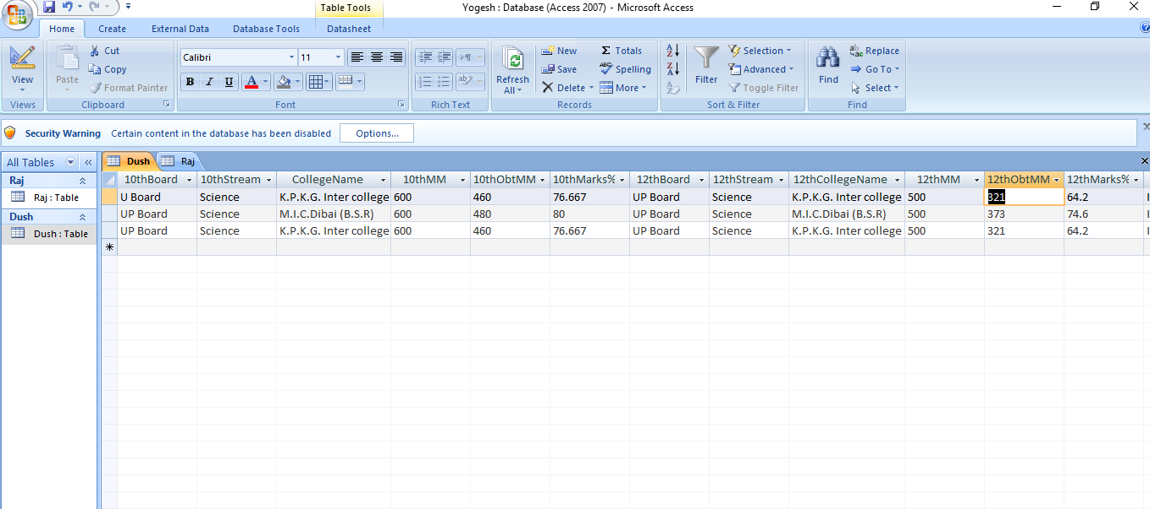

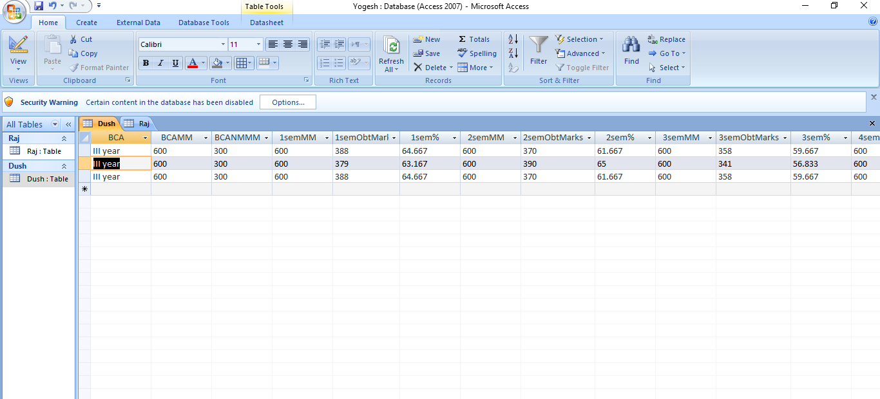

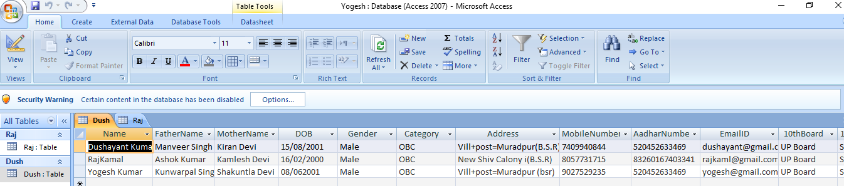

**11. Conclusion**

As evidence of the success of this mission, there are millions of items listed each day in thousands of different categories. And the variety doesn’t stop there. Need a computer? One may find it listed in the proper category, in any configuration from very old and obsolete to the latest greatest machine available. What about antiques? One can find an antique quilt that is up for highest bid, or maybe an old violin, whose beautiful tones have enchanted many though its years. One can even find that special bottle of wine, some aged, exotic cheese, and the perfect ‘mood’ music for that special occasion.

In this instance it may be true that on eBay, they have something for everybody, whatever their tastes may be.

**FUTURE SCOPE OF THIS PROJECT :-**

In future this project can be treated as product according to specification and needs of any organisation.

Since recruitment plays key role in any organization; thus, success over a long period of time and reliance of organization over recruitment is going to be one of the most considered topic for any organization.

Therefore Students Record will be of great help in carrying out book store smoothly and effectively.

At present days every organization is using web technology for their proper functioning, so this web based project is all in all important from college aspects.

**12. BIBLIOGRAPHY**

Java Complete Reference - Herbert Schildt

JDBC NIIT - Reference Book

Introduction to JDBC - Marty Hall, Larry Brown

JDBC Tutorial - Sun Microsystems

Websites - [www.javatpoints.com](http://www.javatpoints.com)

[www.javatutarials.com](http://www.javatutarials.com)

[www.javablogs.com](http://www.javablogs.com)

[www.mysirg.com](http://www.mysirg.com)

|  | |
| --- | --- |
|  |  |
|  |  |